

GSRS 3.2.0 Release Notes
Last Updated: June 2026
Table Contents
Overview 2
Highlighted New Features and Improvements 3
User Roles 3
Angular Upgrade from version 13 to 20 4
Improvements to Product Module 5
Improvements to Application Module 11
Improvements to Impurities Module 12
Improvements to In Vitro Pharmacology Module 13
Improvements to Advanced Search 14
Improvements to Specified Substance G4 Manufacturing (SSG4M) Module 15
Selected Bug Fixes and Improvements 19
Protein Sequence Search Bug 19
Display Name Management 19
Submit Date and Status Date Validation in Application Bug 19
Import JSON in Register Impurities Bug 20

Overview

The GSRS 3.2.0 software release is a minor release. The biggest changes we have made are large-scale efforts that make GSRS more secure and maintainable, but in the user interface, the difference will be minimal.

The biggest changes were
- Changing user roles architecture
- Upgrading the version of the Angular framework used by the frontend.

The update to user roles touches many areas of the software, but is mainly out-of-sight for most users. Similarly, the upgrade to Angular provides greater security, but most of the applications will look very similar to most users. Other improvements and bug fixes are also included in this version; selected highlights are listed below.

Highlighted changes include:
- User Role architecture change
- Frontend Angular 13 to 20 Update
- Updated Product Module
- Updated Application Module
- Updated Impurities Module
- Updated In Vitro Pharmacology Module
- Updated Advanced Search
- Updated Specified Substance Group 4 - Manufacturing Module

Highlighted improvements and bug fixes include:
- Fix to a minor problem that impacted indexing
- Fix Submit and Status Date validation in Application
- Fix Import JSON in Register Impurities

Highlighted New Features and Improvements

User Roles

Purpose and Motivation:
GSRS uses roles to configure what users are allowed to do within the application.
For many years, user role configuration was the subject of confusion. Being able to perform one set of tasks used to require a specific role and users who performed multiple tasks required several roles. On the other hand, application programmers would often check multiple roles before allowing a user to run one task or another. Changing the role associated with a given task generally meant changing the GSRS server code, rebuilding and redeploying.

The new role configuration architecture solves several of these issues:
- Application behaviors are linked to specific privileges.
  - For example, exporting data requires the ‘Export Data’ privilege.
  - These privileges are designed to remain the same.
- Application privileges are assigned to roles.
  - For example, the ‘Export Data’ privilege is assigned, by default, to the ‘Query’ role.
  - The assignment of a privilege to a role is controlled by a configuration file and is therefore easy to change.
- One role may include/inherit the privileges of another role.
  - For example, the ‘DataEntry’ role, designed for users who will be creating new records, includes the Query role. Therefore, users with the DataEntry role can also export data without also getting the Query role explicitly assigned to them.
- Privileges and roles are specified in a configuration file that is loaded when GSRS starts up.
- We include a default role configuration file with GSRS, but organizations are free to change role configuration.
  - For example, importing multi-record data files into GSRS requires the ‘Import Data’ privilege, which is assigned, by default to the Admin role. If your organization wants to enable certain users to import multi-record data files without assigning the Admin role to these users, you can create a new role, such as Importer, and assign the ‘Import Data’ privilege to Importer.
- A privilege can be assigned to more than one role.
  - Alternatively, a privilege can be assigned to one role and additional roles can be configured to inherit the privileges of that role.
How it works:
By convention, the roles configuration file is located in the substance services root directory. You can put the file anywhere as long as you update the ROLES_CONFIG_FILE line of substances-env.conf.

Notes for the future:
We welcome feedback.

Angular Upgrade from version 13 to 20

Purpose and Motivation:
Angular (also referred to as Angular 2) is a TypeScript-based free and open-source single-page web application framework.

How it works:
The Angular framework upgrade from version 13 to 20 is a frontend infrastructure change that primarily affects how the user interface is rendered and maintained, rather than introducing new end-user features.

A major part of this upgrade was the migration of Angular Material components to the MDC (Material Design Components) implementation, which became the standard starting in Angular 15. MDC components introduce updated DOM structures, CSS class names, and styling behavior compared to the legacy components used in Angular 13.

Due to these structural changes, many UI elements—including form fields, buttons, menus, dialogs, lists, and cards—required updates to ensure they continued to display and behave consistently with previous versions.
To preserve the existing look and feel of GSRS, a set of global style overrides and targeted component-level adjustments were implemented. These overrides compensate for differences introduced by MDC and ensure visual consistency across the application without requiring a full UI redesign.

In addition to UI changes, the upgrade included updates to underlying dependencies such as TypeScript, RxJS, and Angular build tooling. Deprecated APIs and legacy configurations were removed or refactored to align with modern Angular standards.

The result is that, while the internal implementation has been significantly modernized, the application appears and behaves nearly the same to end users, with minimal disruption to existing workflows.

Notes for the future:
The Angular framework follows a predictable six-month release cadence, with major versions released each May and November. Staying current with this schedule is important: each Angular major version is actively supported for 18 months, after which it reaches end-of-life and no longer receives security patches. Falling multiple versions behind—as happened between the GSRS Angular 13 and Angular 20 upgrade—means accumulated breaking changes and significantly more effort to catch up. Regular incremental upgrades are far less disruptive than large multi-version jumps.

Angular 22 is scheduled for release in May 2026. Based on the Angular team's published roadmap, the upgrade from version 20 to 22 is expected to bring several meaningful improvements:
- Zoneless change detection: Angular has been progressively removing its dependency on Zone.js, a library that intercepts asynchronous operations to trigger UI updates. The zoneless model, expected to stabilize around this release, improves application startup time and runtime performance.

- Signals-based reactivity: The Signals API, introduced in Angular 16 and steadily maturing, provides a more efficient and explicit way to manage component state. Adopting Signals reduces unnecessary re-renders and simplifies data flow in complex components.

- Improved Server-Side Rendering (SSR): Incremental hydration and better SSR tooling continue to improve, which can benefit page load performance.

- Continued build tooling improvements: The Angular build system (esbuild-based) continues to get faster with each release, reducing local development and CI build times.

Because the Angular Material MDC migration was completed as part of the Angular 13 to 20 upgrade, future upgrades (e.g., Angular 20 to 22) are expected to be significantly less complex. These upgrades should primarily involve running standard Angular migration tools, addressing deprecation warnings, and verifying application behavior, with no major UI component restructuring anticipated.

Improvements to Product Module

Purpose and Motivation:
Several items have been updated in the Product Module, including new validation rules in the Register/Update Product form and features in Browse Product page. An additional validation rule prevents invalid or incomplete data from being entered into the database, which helps maintain data consistency across the system. Also, a new 'Substance Type' facet has been added to the Browse Product page. This facet enables users to filter product records based on substance type categories, including Chemical, Protein, Mixtures, and others.

The dose display format has been updated on the Browse Product and Product Details pages to improve readability and follow standard pharmaceutical conventions. The dose value now appears beneath the Substance Name and combines the Original Numerator Number, Original Numerator Unit, the word "per," Original Denominator Number, and Original Denominator Unit.

Added two new Product Codes PhPID and RxCUI (RxNorm) in the Browse Product, Product Details and Substance Details page. There is a hyperlink under the PhPID and RxCUI codes which take the user to the appropriate websites along with the associated code. The base URL is configured in the frontend config file and can be changed as needed.

How it works:
1. Validation in Register/Update Product page
The Register/Update page now enforces required field validation. When users click 'Validate and Submit' without completing the Product Name, Product Code, or Ingredient Details section, an error message is displayed. This validation prevents incomplete records from being saved to the database. See Figure 1 below.

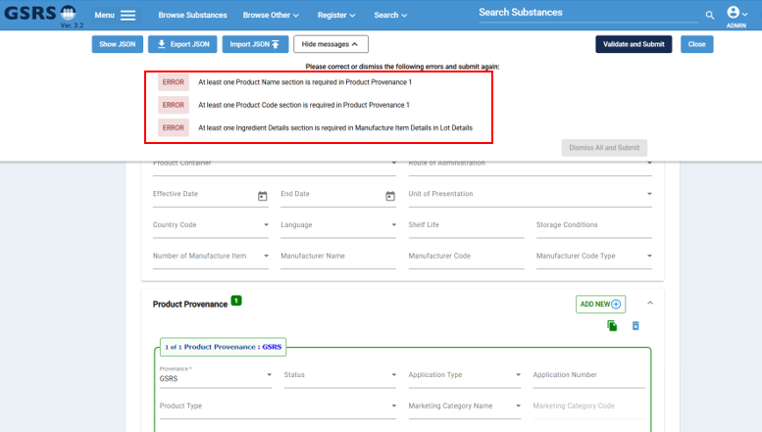
Figure 1: Register/Update Product page – Validation

Additional sub-validations have been implemented within this validation section. If any of the following fields are missing—Product Name, Product Name Type, Product Code, Product Code Type, Ingredient Name, or Ingredient Type—an error message will display when the 'Validate and Submit' button is clicked. See Figure 2 below.
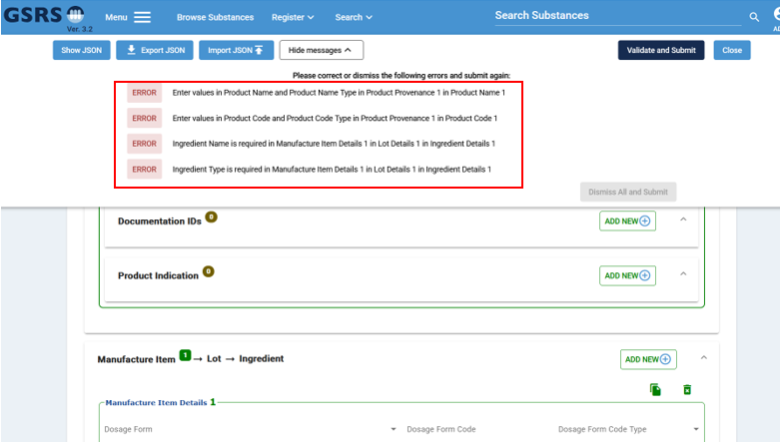
Figure 2: Register/Update Product page – Validation (Continued)

In Register/Update Product page, also added validation for “Amount” field in “Manufacture Item” section. After clicking the Submit button, it should display an error message if the value in the Amount field is not a number. No character is allowed in this field and prevent entering invalid data. See Figure 3 below.
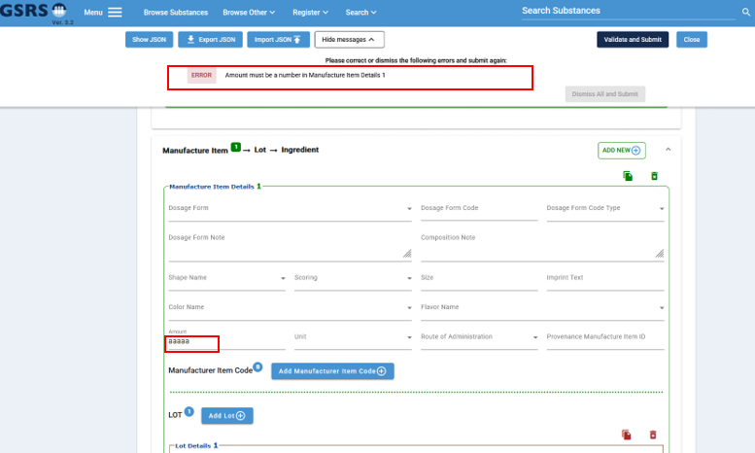Figure 3: Register/Update Product page – Validation (Continued)

2. Browse Product page
Various improvements have been implemented on the Browse Product page to enhance user experience, improve usability, and enable more efficient data display.

2a. Displaying "Substance Type" facet to the Browse Product page to enhance search and filtering capabilities. This facet allows users to refine their product search results by selecting specific substance type categories, such as Chemical, Protein, Polymers, Mixtures, and other classification types. By providing this additional filtering option, users can more efficiently locate products based on their substance composition, reducing the time needed to navigate through large datasets. The Substance Type facet works in conjunction with existing filters on the Browse Product page, enabling users to combine multiple search criteria for more precise results. See Figure 4 below.

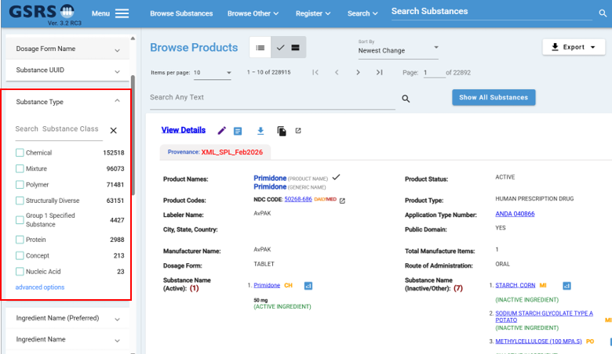
Figure 4: Browse Product page – Substance Type facet

2b. The Browse Product page and Product Details page now display Substance Type information next to the Substance Name to help users quickly identify the type of substance associated with each product. Due to space constraints in the frontend UI, Substance Types are shown using abbreviated codes rather than full names: 'CH' for Chemical, 'PR' for Protein, 'PO' for Polymer, 'MI' for Mixture, 'NA' for Nucleic Acid, 'SD' for Structurally Diverse, 'CO' for Concept, and 'SSG1' for Specified Substance Group 1. To ensure clarity, users can hover their mouse over any abbreviated code to view a tooltip popup that displays the full Substance Type name (e.g., hovering over 'CH' shows "This Substance Type is Chemical"). See Figure 5 below.

This enhancement allows users to immediately see the substance classification of Active Substance(s) and Inactive Substance(s) without going to the Substance Details page. This allows users to display data without cluttering the interface, improving data readability and user experience while maintaining efficient use of screen space. Additionally, this feature improves product comparison capabilities, reduces cognitive load during data scanning, and supports specialized workflows for teams that focus on specific substance categories.

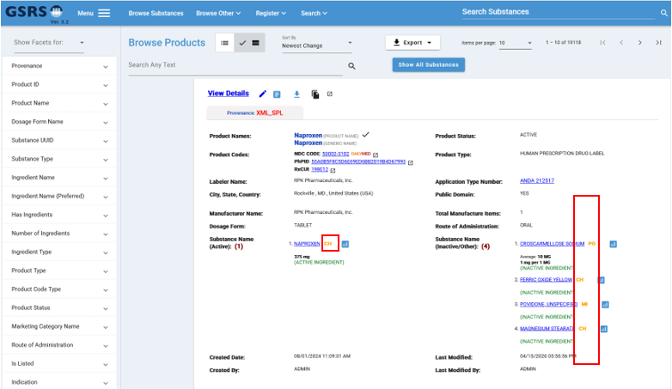
Figure 5: Browse Product page – Substance Type Text

2c. In Browse Product and Product Details pages, dose display format has been updated to improve readability and align with standard conventions. The dose value now displays as a combination of the numerator and denominator values, adding the word "per," in between. Now under the Substance Name, it displays the combination of Original Numerator Number and Original Numerator Unit and add "per" before Original Denominator Number and Original Denominator Unit. So, the display format looks like ".12 mL per 6 mL". See Figure 6 below.

Also, if the values of Original Denominator Number and Original Denominator Units are equal to 1, then do not display 1, 1, and "per" on the browser. So, it will look like "20 mg". This enhancement provides a cleaner, more intuitive presentation of dose information that aligns with how healthcare professionals typically read and interpret dosage data, making it easier for users to quickly understand product strength and formulation details.
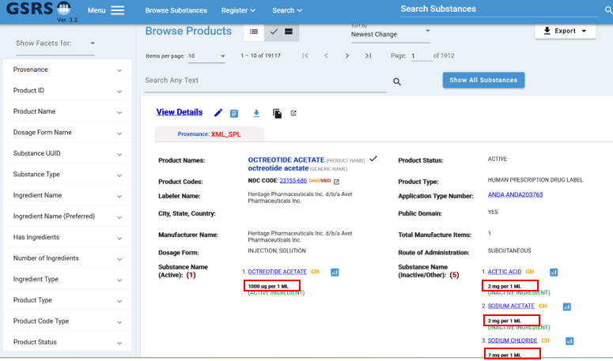
Figure 6: Browse Product page – Strengths and Units

2d. New hyperlinks for Product Code and Product Code Type such as PhPID RxCUI and (RxNorm) have been created and integrated across multiple pages within the Product Module. On the Browse Product page, two new links have been added below the NDC Code: "PhPID " and "RxCUI ". See Figure 7 below.
The Register/Update Product page has been updated to include two new controlled vocabulary (CV) values—PhPID and RxCUI—in the "Product Code Type" dropdown field within the Product Code section, which are managed through the Admin Panel under the "PROD_PRODUCT_CODE_TYPE" domain. Additionally, the Product Details and Substance page now displays PhPID codes and RxNorm codes with their associated hyperlinks in the Product Code field, positioned below the NDC code. These fields are currently configured to accept data but may remain blank until populated with information from a future data source. See Figure 8 below.
Additionally, a configuration-based system has been implemented to enable automatic updates of PhPID and RxCUI (RxNorm) hyperlinks across the application. The PhPID and RxNorm links have been added to the frontend configuration file, allowing centralized management of these URLs. The keys in the config file are "phpIdUrl" and "rxNormUrl". The Browse Product, Product Details, and Substance Details pages now dynamically read these links from the configuration file and concatenate the respective PhPID or RxCUI codes to generate complete hyperlinks, ensuring that any future changes to these external resources can be updated in one location without modifying individual page code.
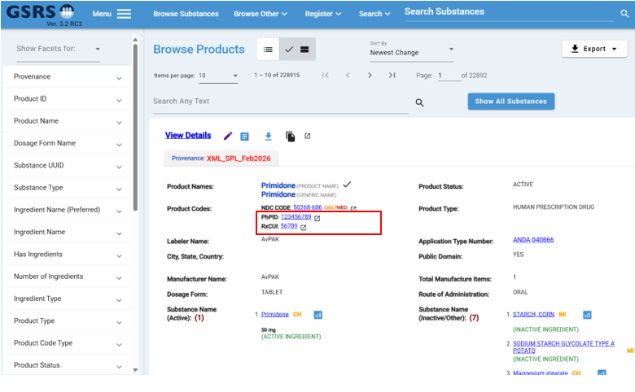
Figure 7: Browse Product page – PhPID and RxCUI
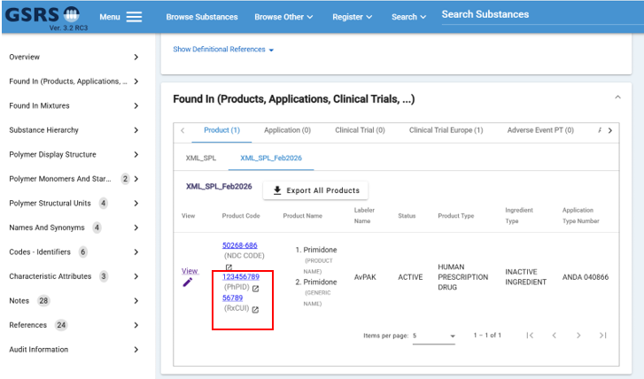
Figure 8: Substance Details page – PhPID and RxCUI
Notes for the future:
In the future, there will be more improvements in Product Module.

Improvements to Application Module

Purpose and Motivation:

A visual indicator has been added to the Browse Application and Application Details pages to clearly identify records with restricted public access. When a record's Public Domain field is set to "NO," a lock icon now appears next to the record, providing users with immediate visual feedback about the record's accessibility status.
How it works:

On the Browse Application page, the lock icon appears in the record listing next to each application where the Public Domain value is "NO." This allows users to scan through search results and quickly identify which applications have restricted access before clicking into the details. See Figure 1 below. Also, the Application Details page shows the lock icon next to the Application Type and Number to alert users that the record has restricted access and must be handled appropriately.

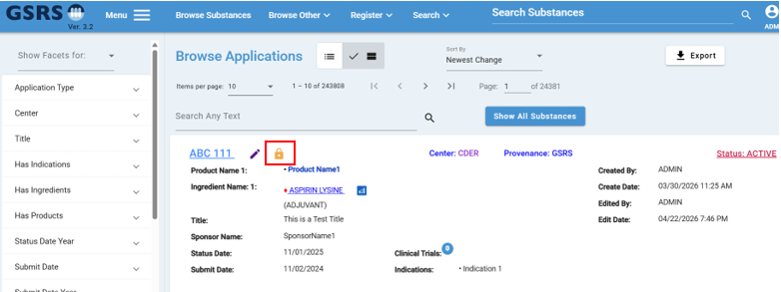
Figure 1: Browse Application page – Lock Icon

Notes for the future:
In the future, there will be more improvements in the Application Module.

Improvements to Impurities Module

Purpose and Motivation:

The Register/Update Impurities page requires users to enter test data along with associated child records, which can be time-consuming when multiple similar test entries are needed. To improve efficiency and reduce repetitive data entry, a Copy button has been added to the Test section.

How it works:

A Copy button has been added to the Test section on the Register/Update Impurities page to streamline data entry and improve user efficiency. When clicked, this button duplicates the entire Test section along with all associated child records, allowing users to quickly create multiple similar test entries without manually re-entering data. This enhancement reduces repetitive work, minimizes data entry errors, and provides a more efficient workflow for users who need to register or update multiple tests with similar configurations. See Figure 1 below.

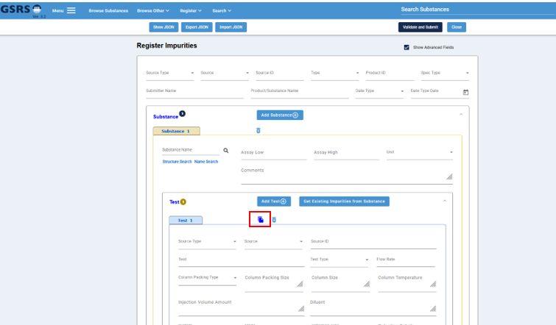

Figure 1: Register Impurities page – Copy button

Notes for the future:
In the future, there will be more improvements in Impurities Module.

Improvements to In Vitro Pharmacology Module

Purpose and Motivation:

The Browse In Vitro Pharmacology (IVP) page lacked essential audit-related filtering capabilities that are standard across other browsing pages in the system. Users were unable to search or filter records based on audit trail information, which limited their ability to track record history and identify recent changes or new entries.

How it works:

Three audit-related facets were missing from the Browse In Vitro Pharmacology (IVP) page, limiting users' ability to search and filter records based on audit criteria. The missing facets "Record Create Date," "Record Last Edited," and "Record Last Edited” are now have been added to the IVP browse page. These facets enable users to filter and search In Vitro Pharmacology data based on when records were created, when they were last modified, and who made the most recent edits. This enhancement improves data traceability and allows users to track record history more effectively, supporting audit requirements and making it easier to identify recently updated or newly created records. See Figure 1 below.

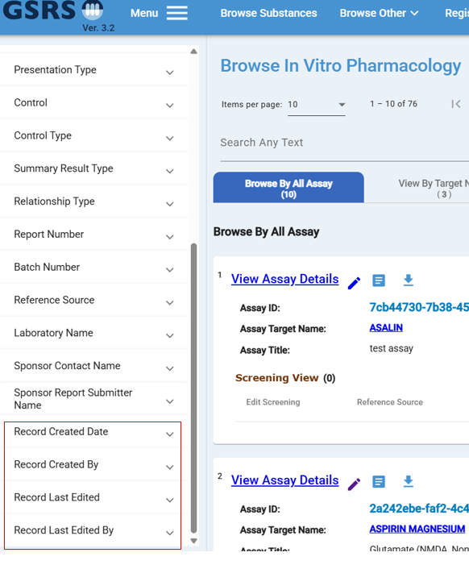
Figure 1: Browse In Vitro Pharmacology page – Audit Facets
Notes for the future:
In the future, there will be more improvements in In Vitro Pharmacology Module.

Improvements to Advanced Search

Purpose and Motivation:

In Advanced Search, in the Application tab, when a user selects "Substance Key" from the "Search In Fields" dropdown, the system now displays existing Substance Key values with Typeahead functionality. This enhancement has been implemented to improve user experience by automatically showing suggestions as the user types, making it easier to select from existing values without needing to know the exact Substance Key.

How it works:

When a user selects "Substance Key" from the "Search In Fields" dropdown and begins typing in the search textbox, the system automatically searches the Lucene index for matching Substance Key values. The Substance Key value can either be BDNUM, Substance UUID, or Approval ID. The backend finds all Substance Keys that match what the user has typed and sends these results back to the frontend. The matching suggestions appear in a dropdown list below the textbox, showing the user all available options. See Figure 1 below. The user can then select a Substance Key from the list, which fills in the textbox with that value. After selecting a value and clicking the "Search" button, the system finds all Application records associated with that Substance Key. The page then displays these results on the Browse Application page, making it easier for users to search without knowing exact Substance Key values.
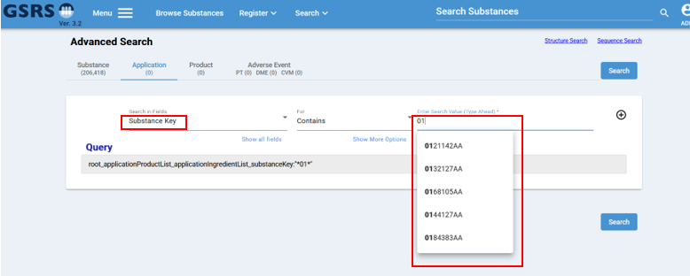
Figure 1: Advanced Search – Application Tab page

Notes for the future:
In the future, there will be more improvements in Advanced Search.

Improvements to Specified Substance Group 4 - Manufacturing (SSG4M) Module

Purpose and Motivation:

Several improvements have been made to the Specified Substance Group 4 - Manufacturing (SSG4M) module — also referred to as G4SSM — to simplify the user interface, improve data export, and allow related draft substances to be referenced and submitted alongside the main SSG4M record. These changes address pain points observed during day-to-day registration of synthetic manufacturing pathways. Previously, Sponsors and the Public could only populate the form with substances previously registered in GSRS. Users can now temporarily register a reference substances from their local environment, bringing the application functionalities closer to the full experience available within FDA’s firewall.

The Scheme View tab has been removed from the SSG4M form. Step View (which presents the pathway as a sequential list of reaction steps) was retained, because it has proven to be the primary view used by registrars and reviewers. The legacy graph-based Scheme View duplicated this information and added load-time overhead from third-party visualization libraries (cola.min.js and related). The Step View can still be exported as an SVG and embedded in the saved substance record. This export is now opt-in via configuration so that users can disable it if the environments do not need it.

A long-standing limitation of the SSG4M form was that every substance in a stage (input, process, resulting) had to be a persisted substance (i.e., there may be a lag time between updates from GSRS to a downstream system which would prevent user from finding a registered substance). Registrars and Sponsors often need to reference brand-new substances that have not yet been registered. To support this workflow, the SSG4M form now allows users to reference substance drafts stored in the browser's local storage as materials. When the main SSG4M record is submitted, any referenced drafts are automatically validated and submitted first, then the SSG4M record itself is saved. To make drafts addressable as references, every saved draft now receives a generated UUID (previously many drafts shared the placeholder value “register” and could not be uniquely identified). For drafts that contain a chemical structure, a temporary structure identifier is created on selection so the same image-rendering pipeline used for persisted substances can preview the draft's structure inside the SSG4M form.

Finally, a Save Local Batch action has been added that downloads the in-progress SSG4M JSON together with every draft it references, so a registrar can hand off a complete, self-contained working set as a set of files.

How it works:

1. Scheme View hidden; Step View retained

The Scheme View tab has been removed from the SSG4M Process card. Only the Form View and Step View tabs are now displayed. The internal schemeUtil initialization, the dynamic loading of cola.min.js and related visualization libraries, and the related callbacks have been disabled. The app-ssg4m-scheme-view component itself is still used to render the Step View content, so existing pathway rendering behavior is preserved inside Step View. See Figure 1 below.
Figure 1: SSG4M Process card — Form View and Step View tabs (Scheme View removed)

2. Configurable Step View SVG export
A new boolean configuration flag, ssg4mExportSvg, has been added to the frontend configuration (config.json). When `true`, the Step View is expanded and exported as an SVG that can be embedded in the saved SSG4M record on submission. When `false` (the default), this SVG export is skipped, which makes form submission faster. The flag is intended to let each deployment decide whether the SVG snapshot is needed. See Figure 2 below.
// assets/data/config.json
{
"ssg4mExportSvg": true
}

Figure 2: config.json — ssg4mExportSvg flag

3. UUID generation for substance drafts

The system now generates unique UUIDs for new substance drafts saved via the registration form. This replaces the previous method of using a generic placeholder, which prevented unique identification and cross-referencing. These generated IDs are visible in the UUID column of the Substance Drafts dialog, where multi-selection have also been added for better usability. See Figure 3 below.
Figure 3: Substance Drafts dialog — generated UUID column and multi-selection

4. Referencing and submitting drafts from the SSG4M form
The Substance Selector in SSG4M now includes a "Use Draft" option. When a registrar selects a draft, its unique identifier is linked to the material slot. If the draft includes chemical structure data, the system retrieves a temporary ID to provide a structure preview directly within the form. Upon submission, the application performs the following sequence:

- It identifies all drafts referenced across the manufacturing process.
- Referenced drafts are validated against the server; any resulting messages are clearly labeled with the draft's name.
- Validated drafts are persisted prior to the main record. See Figure 4 below.
- Temporary identifiers are removed to ensure data cleanliness.
- The complete SSG4M record is submitted.
Figure 4: SSG4M form — referenced draft validated. Top – Error or warning messages will appear if the record in draft has issues. Bottom – Example of record validated successfully.
5. Save Local Batch
A new Save Local Batch command has been added to the save menu. This action packages the active SSG4M record and all its referenced drafts into individual JSON files. This creates a portable, comprehensive data set suitable for archival or for sharing with other team members. See Figure 5 below.
Figure 5: SSG4M form — Save Local Batch action

6. Structure image rendering for drafts

Updates to the substance image directive allow draft chemical structures to be visualized within the SSG4M module before they are saved to the server. By interpreting the structure and assigning a temporary ID, the selector can display high-quality previews, which brings draft material previews to visual parity with approved substances. See Figure 6 below.
Figure 6: SSG4M Stage — draft material structure image preview in Step View

Notes for the future:
In the future, there will be more improvements in the Specified Substance G4 Manufacturing (SSG4M) Module.

Selected Bug Fixes and Improvements

Protein Sequence Search Bug
There was a bug in the processing of search results for protein sequences under certain specific conditions.
This bug occurred when a protein consisted of 2 more subunits where the sequences were very similar (>95%) but had some differences. The overall similarity of the 2 subunits must be greater than the cutoff used in the sequence search.
One such protein is Remigromig (UNII C3TZ3X6VNV). The first 2 subunits have similar sequences with a few differences. When you use the first sequence in a sequence search, using the default cutoff of 0.95, the first hit is the second sequence with a similarity of 0.960 which can be misleading.

Display Name Management

Updated the existing Names Validator to prevent ordinary data editors from changing the display name of a validated substance.
Previously, it was possible for any user with write access to make changes to the display name of any substance. This change has the potential to confuse users of the data because substances are known by their display names.
Now, only users with the “Change Display Name for Approved” privilege may change the display name for a validated substance. Currently, the “Change Display Name for Approved” is assigned to users with the Approver role.
Any user with the Edit privilege may change the display name for a pending substance.

Submit Date and Status Date Validation in Application Bug

A validation error has been identified and fixed on the Register/Application page related to the Submit Date and Status Date fields. The issue occurred when users entered certain date combinations and changed the dates again, which triggered an error. The error appeared when the Status Date was changed the second time. The validation logic has been corrected to properly handle date entries and prevent these errors from occurring during application registration.

Import JSON in Register Impurities Bug

The Import JSON functionality on the Register Impurities page has been fixed to resolve an issue where the page would continuously spin without successfully importing the JSON file. Previously, when users attempted to import a JSON file on the register page, the system failed to populate the form with the file data, leaving the page in a loading state. The issue has been corrected to ensure JSON files are properly imported and the form fields are populated as expected and able to save into the database.

From Wikipedia, https://en.wikipedia.org/wiki/Angular_(web_framework)

